Alexandra House  33 Kingsway  London  WC2B 6SE | T 08456 404040  F 020 7421 6855  enquiries@ofsted.go.uk  www.ofsted.gov.uk |  | 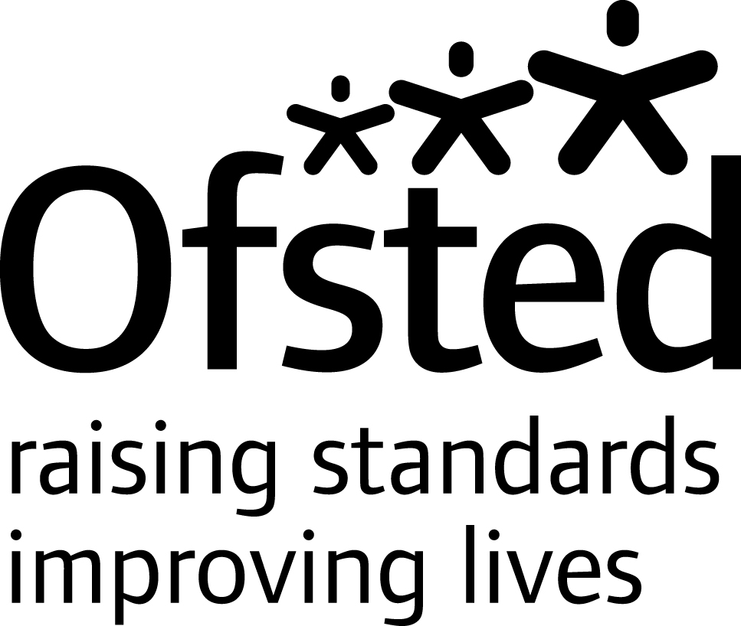

25 January 2008

Mrs J H Mott
Headteacher
Hollinhey Primary School
Bell Avenue
Sutton
Macclesfield
Cheshire SK11 0EE

Dear Mrs Mott

Ofsted survey inspection programme: English

Thank you for your hospitality and co-operation, and that of your staff, during my visit on 23 January 2008 to look at work in English.

As outlined in my initial letter, as well as looking at key areas of the subject the visit had a particular focus on our current survey theme: independent learning in English. The visit provided valuable information which will contribute to our national evaluation and reporting. Published reports are likely to list the names of the contributing institutions but individual institutions will not be identified in the main text.

The evidence used to inform the judgements made included: interviews with staff and pupils, scrutiny of relevant documentation, analysis of pupils’ work and observation of two lessons. The overall effectiveness of English was judged to be good.

Achievement and standards

Standards are above average in English and pupils’ achievement is good.

- Standards have risen and were above average in the national tests at the end of Key Stage 2 in 2007. Standards at the end of Key Stage 1 are above average in reading but average in writing.
- The contextual value added data shows that achievement from Key Stage 1-2 has been good over the past two years. There was especially good progress by able pupils last year.
- Boys achieved as well as girls in the national tests last year. This is better than the national picture although the school’s own data does not confirm that this trend will continue.
- Standards observed during the inspection were above average especially in speaking and listening; many of the pupils communicate well and make use of mature language when talking to adults.
- English makes a good contribution to pupils’ personal development, especially through drama which helps pupils to develop self confidence.

Quality of teaching and learning of English

The quality of teaching and learning is good.

- Feedback from pupils about English lessons was broadly positive, particularly for older pupils who described English lessons as lively and enjoyable. All pupils had enjoyed drama lessons.
- Lessons observed were well planned and had good relationships with pupils. In one lesson, pupils were motivated by interesting content which included moving image work and speaking and listening. In the second, phonics was taught in line with recommendations of the National Primary Strategy and pupils were seen to be making good progress.
- In both lessons, some opportunities were missed to develop aspects of independent work, especially for the more able pupils.
- Teachers respond to pupils’ work with positive and encouraging comments. Consistent use is made of curricular targets. Despite this, most pupils were very uncertain about what they needed to do in order to improve their work.

Quality of curriculum

The curriculum in English is good.

- There are some interesting features to the curriculum in English. The Friday afternoon provision for a variety of activities provides good opportunities for enrichment. This includes work by different groups of pupils on the media through producing the Kids News.
- Drama makes a very good contribution to pupils’ literacy development alongside the current emphasis on speaking and listening.
- The curriculum includes a good emphasis on extended writing, for instance in autobiographical writing in Year 6 and the non fiction topic in Year 4.

Leadership and management of English

Leadership and management are good in English.

- The subject coordinator provides good leadership in English. She is an effective classroom practitioner and thus in a good position to identify and share good practice.
- There is a clear sense of direction to work in English. The school is currently implementing the suggested changes in the Primary National Strategy, including a more systematic approach to phonics
- The school sets challenging targets. This is especially relevant since the school receives a number of pupils who are significantly above average in English.
- Approaches to monitoring and evaluation are well structured and include regular lesson observations by the subject leader and the annual work scrutiny.
- The school has worked closely with other local primary schools in order to develop and share good practice.

Independent learning in English

Independent learning in English is satisfactory.

- Approaches to homework are systematic and consistent. Some homework set gives pupils good opportunities to work independently, for instance asking them to interview members of their family and to conduct research. Many homework tasks are relatively conventional and mostly teacher directed.
- Independent reading is promoted through home reading books and reading diaries. However, the quality of pupils’ writing in their diaries is no more than satisfactory and more should be done to extend and support pupils’ reading outside school.
- Drama and oral work helps pupils to develop initiative and independence.
- Some activities such as the Kids News project enable pupils to work together and develop independent learning skills.

Inclusion

- The school provides a range of intervention programmes for pupils, depending on needs, from year to year. The school’s own evaluation suggests mixed success in raising standards although the programmes have contributed to pupils’ greater self confidence.
- No group of pupils under-achieved in the national tests for Year 6 last year; both boys and girls made good progress.

Areas for improvement, which we discussed, included:

- developing pupils’ understanding of how to improve their work in English through better feedback and more effective target setting,
- reviewing the use of reading diaries in order to support and extend pupils’ independent reading more effectively, and
- identifying more opportunities in class work and homework to give pupils greater choice and independence.

I hope these observations are useful as you continue to develop English in the school.

As I explained in my previous letter, a copy of this letter will be sent to your local authority. All feedback letters will be published on the Ofsted website at the end of each half-term and made available to the team for the next institutional inspection.

Yours sincerely

Philip Jarrett HMI
Subject Adviser for English

