

ICT Acceptable Use Policy
Pupil Agreement

These rules are a reflection of the content of our school’s Online Safety Policy. It is important that parents/carers read and discuss the following statements with their child, understanding and agreeing to follow the school rules on using ICT, including use of the Internet.

- I will only use ICT in school for school purposes.
- I will only use the Internet and/or online tools when a trusted adult is present and with permission.
- I will not deliberately look for, save or send anything that could be unpleasant or nasty.
- I will not deliberately bring in inappropriate electronic materials from home or post inappropriate material on TEAMS.
- I will not deliberately look for, or access inappropriate websites.
- If I accidentally find anything inappropriate I will tell my teacher immediately.
- I will only communicate online with people a trusted adult has approved.
- I will make sure that all ICT contact with other children and adults is responsible, polite and sensible including on TEAMS.
- If using Video meetings in school or at home, I will behave according to the Remote Learning Code of Conduct.
- I will not give out my own, or others’ details such as names, phone numbers or home addresses.
- When communicating with adult members of staff on TEAMS or via email, I will be respectful and courteous at all times
- I will not attempt to communicate with members of staff via social media or other non-Hollinhey forms of communication.
- I will not tell other people my ICT passwords.
- I will only open/delete my own files.
- I will not bring external memory sticks, flash drives or USB sticks into school.
- I will not attempt to download or install anything on to the school network or iPads without permission.
- I will be responsible for my behaviour when using ICT because I know that these rules are to keep me safe.
- I know that my use of ICT can be checked and that my parent/ carer contacted if a member of school staff is concerned about my E-Safety.

Our Golden Rules for
Staying Safe with ICT in FS/KS1

We only use the Internet and the computers when a trusted adult is with us.

We are always polite, sensible and friendly when using ICT.

We always make careful choices when we use the Internet.

We always ask a trusted adult if we need help using the Internet.

We always tell a trusted adult if we find something that upsets us.
We never speak, message or send pictures to someone we do not know.

Our Golden Rules for
Staying Safe with ICT in KS2

We always ask permission before using the internet.

We only use the Internet when a trusted adult is with us.
We immediately minimise any page we are
uncomfortable with (or if possible switch off the monitor)

We always tell an adult if we see anything we are uncomfortable with.

We only communicate online with people a trusted adult has approved.

All our online communications are polite, sensible and friendly.

We never give out our own, or others’, personal information or passwords and are very careful with the information that we share online.

We only use programs and content which have been installed by the school.

If using Video meetings or TEAMS in school or at home, we will behave according to the Remote Learning Code of Conduct.

ICT Acceptable Use Policy
Pupil Agreement

Please return just this page after discussing with your child and signing that they understand and agree to these rules. Please use a separate form for each child.
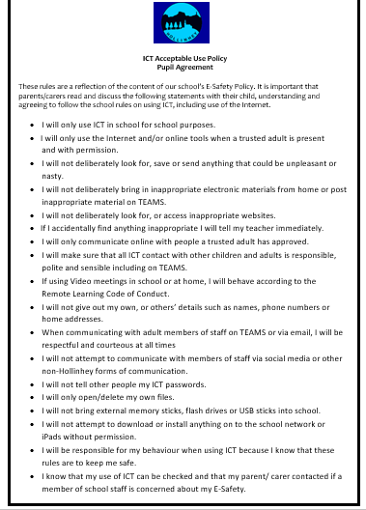
Thank you.

We have discussed this Acceptable Use of ICT Policy and what it means.

……………………………………………………………... [Print child’s full name] agrees to

follow the Online Safety rules and to support the safe use of ICT.

Parent /Carer Name (Print) ….………………………….……….………………………….

Parent /Carer (Signature)….…….……………….…………………………………………

Date…………………………

